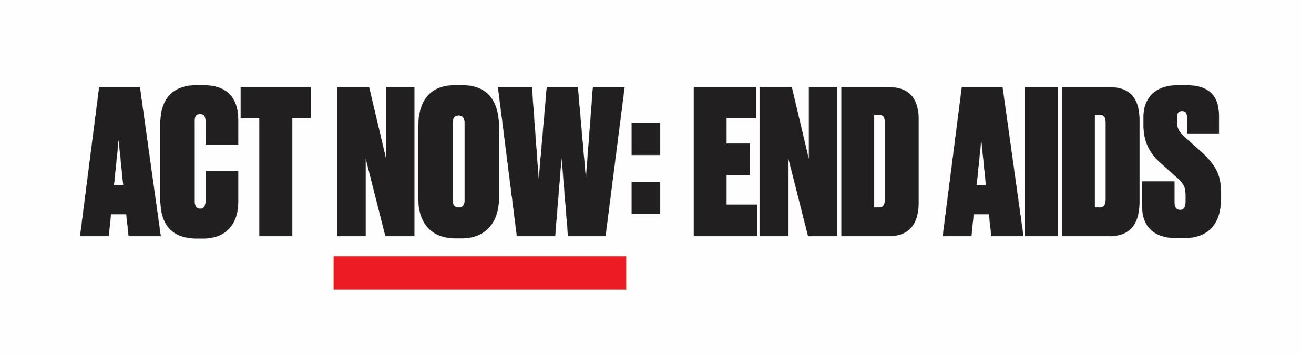
Application to express interest in ACT NOW: END AIDS small grants
Open to community-based organizations and coalitions serving in one or more of the 57 jurisdictions named in the federal Ending the HIV Epidemic initiative.
A list of jurisdictions can be found here: https://files.hiv.gov/s3fs-public/ending-the-hiv-epidemic-counties-and-territories.pdf

Please submit completed form to ANEA@treatmentactiongroup.org, attaching a letter of support from the board, or any other affiliated organization(s) by November 6, 2019, 5pm EST.

Organizational information:

Name of organization/coalition:
Address of organization/coalition:
Name of point(s) of contact:
Gender pronouns for point of contact:
Mailing & office address:
Phone number (landline/cellphone):
Primary E-mail:
Secondary E-mail:
Website:
Facebook:
Twitter:

Expression of interest:

- Describe your organization/coalition’s previous and current work related to HIV advocacy (150- words maximum):

- Why is your organization/coalition interested in advocacy to support community leadership as part of the new Ending the HIV Epidemic: A Plan for America initiative? (100 words maximum)

- Please identify the three most impacted (rate of HIV incidence or mortality) subpopulations in terms of race/gender/sexuality/mode of infection (or some intersection of those characteristics) per available HIV surveillance data.

- What role do members of these subpopulations play in the leadership (i.e. board or executive staff) of your organization/coalition? (100 word maximum)

- Identify the total percentage of these subpopulations that serve on your board and in senior leadership. (Example: Your jurisdiction’s surveillance data identifies transgender Latina women, black gay men, and white heterosexual men who use drugs as the three most impacted populations. Your board has five members. Two self-identify as one of those three subpopulations; therefore, 40% of your board reflects the most impacted subpopulations.)
Board: _______%
Senior Leadership: _______%

